International
Marketing-
Hand Tools

Group: LAP
Group Members:
Ariel S0941007
Angela S0941052
Alia S0911029
Phoebe S0963061
Lou S0963063
National Changhua University of Education
Department of Business Administration
International Business
Dr. James Stanworth
April 15, 2024

Table of Contents
Introduction 2
STP Analysis 2
Segmenting 2
Targeting 3
Positioning 4
4P Analysis 5
Product 5
Price 7
Place 7
Promotion 8
Service Support 9
Conclusion 10

Introduction
Following the previous report, we plan to import our hand tool brand Gorilla into Japan for sale. We will focus on our target customers and product positioning through STP analysis. Subsequently, we will use the 4P analysis to establish reasonable pricing, find suitable sales channels, and develop effective promotional methods, forming a complete marketing mix.

STP Analysis

Segmenting

Geographic
- Japan is located in Northeast Asia and is geographically divided into four main parts, commonly called the four major islands. These islands are Hokkaido, Honshu, Shikoku, Kyushu. We segment Honshu as our target country.
Figure 1- Map of Japan
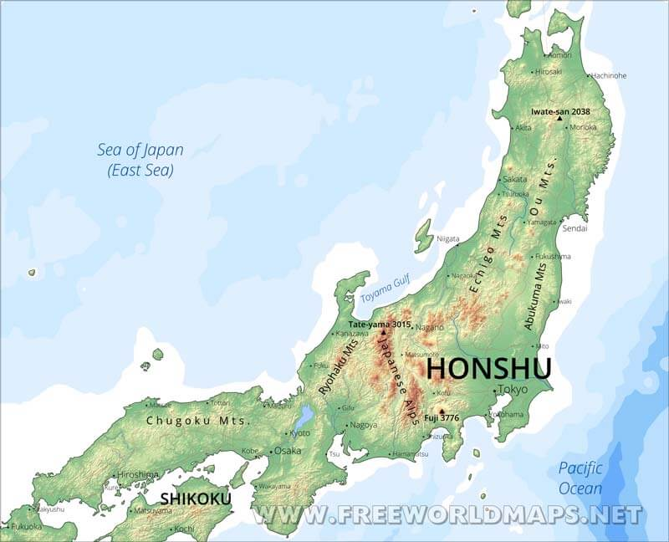
Source:https://www.freeworldmaps.net/asia/japan/honshu.html

Demographic
For the population age distribution, we divide Japan into 3 main categories: population under 15, between 15 and 64 years old, and over 65. Population under 15 accounts for 13.1%, the population between 15 and 64 years old accounts for 64%, and the population over 65 accounts for 22.9%.

Figure 2- Japanese population age distribution
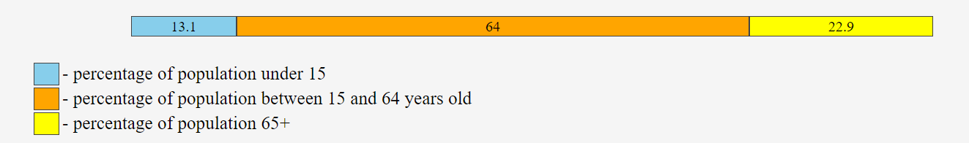
Source: https://countrymeters.info/en/Japan

To be in absolute figures (estimate):

16,544,234 young people under 15 years old ( 8,494,632 males / 8,050,863 females)
80,685,132 persons between 15 and 64 years old ( 40,685,478 males / 39,999,654 females)
28,841,152 persons above 64 years old ( 12,236,404 males / 16,604,748 females)

Psychographic
In the psychological part, we focus on 2 aspects, lifestyle and common hobbies. For lifestyle, we divide into urban lifestyle, traditional lifestyle, and rural lifestyle. We divide common hobbies into three main hobbies: reading (including manga, anime, and comics), gardening, karaoke, and cooking.

Targeting
Geographic
- Population Density: Honshu is the most populous island, containing major cities like Tokyo, Yokohama, Osaka, and Kyoto. A higher population density means more households and businesses engaged in gardening and floral arrangements.
- Cultural Centers: Cities such as Kyoto and Tokyo are cultural centers with a rich tradition of gardening and ikebana (the Japanese art of flower arranging), both of which require the use of floral shears.
- Gardening and Floral Events: Honshu hosts numerous gardening shows, floral exhibitions, and festivals, where the use of floral shears is common. For instance, the Tokyo International Garden Show and various ikebana exhibitions attract many enthusiasts and professionals.
- Commercial Floriculture: Honshu has a significant number of commercial floriculture businesses and flower markets, especially in Tokyo, which is home to the famous Ota Market, one of the largest flower markets in the world. These businesses heavily rely on floral shears.
- Educational Institutions: Many of Japan's leading horticultural and floral design schools are located on Honshu, contributing to a high demand for floral shears among students and professionals.
Given these factors, Honshu is the island where the use of floral shears is most prevalent.
lifestyle and common hobbies
Professional Florists
- They have high demands for the professionalism, durability, and functionality of their tools.
- They have high expectations for the design and quality of the product.
Gardening Enthusiasts
- They enjoy engaging in floral arrangements and gardening work themselves.
- They emphasize the aesthetics and ease of use of the tools.
Household Users
- They need tools for simple floral trimming and gardening tasks at home.
- They require convenient and easy-to-use tools.

Positioning
Compared with other hand tools in Japan, we think that:
Floral Shear is a convenient and easy-to-use household gardening tool
- Emphasize ergonomic design and ease of use.
- Suitable for household users and gardening enthusiasts.
- It is not very multifunctional.

Figure 3- Comparison of Hand Tools in Japan
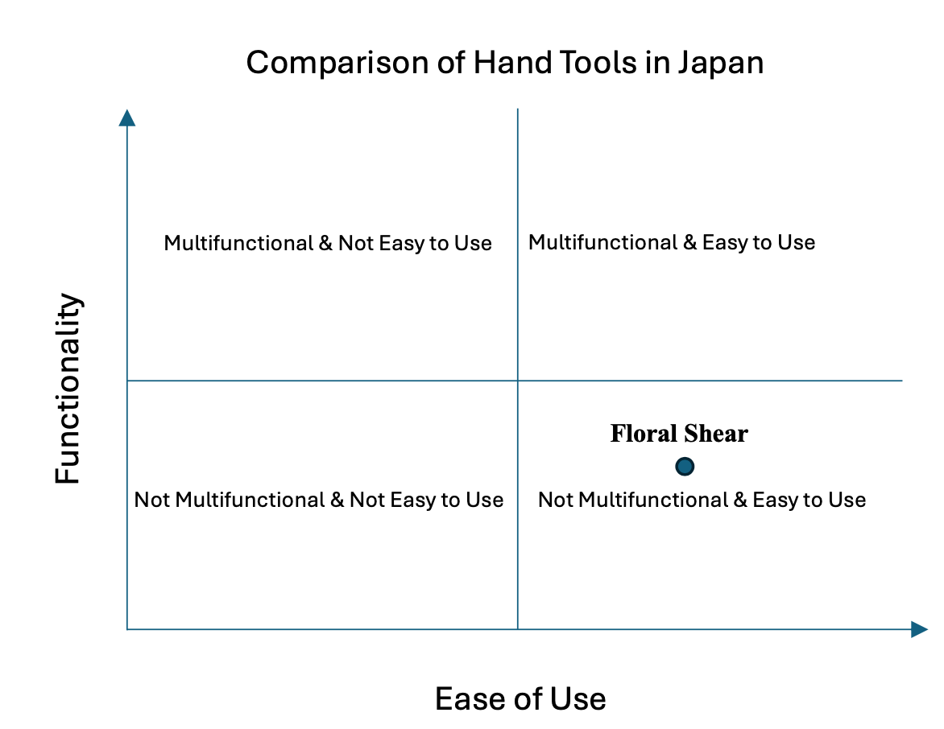

4P Analysis

Product
- These floral shears adopt a special 1:3 ergonomic design, with a golden ratio between the blade and handle that makes the cutting angle more ergonomic. Additionally, they weigh only 210 grams, significantly reducing the burden on the user's hand and wrist. This design is particularly suitable for middle-aged and elderly individuals who engage in gardening for extended periods, as it is both effortless and comfortable. It effectively meets the needs of the elderly for lightweight, comfort, and reduced fatigue.
- The handle of these floral shears is made of non-toxic and durable TPR and PP materials, compliant with the EU REACH environmental regulations and has passed 191 toxicity tests to ensure safety and non-toxicity while providing a comfortable feel. The special groove design and soft handle material not only offer a non-slip grip but also reduce palm pain and fatigue during extended use. These features meet the needs of middle-aged and elderly individuals aged 50 to 65 for comfort, ease of use, and safety in floral shears, making the gardening process more effortless, comfortable, and safe.
- The replaceable blade design of these floral shears allows users to easily replace worn or damaged blades at home with just a 5mm hex wrench or hex screwdriver bit. This extends the lifespan of the shears and enhances their environmental friendliness. Additionally, users can switch blades based on different gardening needs, enabling the same tool to be used in various situations. This design particularly satisfies the middle-aged and elderly's need for durability, versatility, and eco-friendliness in their tools.
Figure 4 - The replaceable blade design
Source : https://reurl.cc/NQoKM5

- This floral shear features a one-handed quick release locking design, allowing users to swiftly unlock and lock the shear with just one hand. Upon unlocking, the shear automatically springs open, reducing operational burden, and can be quickly locked again after use. This feature is particularly suitable for middle-aged and elderly individuals with lower hand dexterity, offering ease of operation and efficiency, meeting their needs for convenience and usability.
- This floral shear is equipped with a robust and durable high-grade spring, ensuring excellent performance over extended periods of use. Even if damaged, the spring can be easily replaced. Furthermore, Gorilla offers free maintenance services within three years (excluding the blades), alleviating users' concerns about the risk of damage to their high-quality hand tools and enhancing the product's reliability and trustworthiness. These features cater to the needs of middle-aged and elderly individuals for tool durability, long-term performance, and after-sales support.
- This floral shear is crafted from premium Japanese SUS420J2 martensitic stainless steel, boasting surgical-grade hardness (HRC50-54). It undergoes top-tier Japanese heat treatment techniques to enhance its sharpness and durability. It effortlessly cuts various floral materials, bonsai, seedlings, and thick branches up to 16mm in diameter. These features cater to the needs of individuals aged 50 to 65 for high-quality blades, enabling them to easily trim plants of varying thicknesses and hardness, reducing the hassle of frequent tool replacement, and ensuring optimal performance over the long term.
- Gorilla's replaceable stainless steel floral shears are 100% manufactured in Taiwan, utilizing the heat treatment, precision forging, and top-notch grinding techniques of Taiwan's premier factories with over 40 years of experience. This ensures that the blade edge hardness reaches up to HRC50-54, guaranteeing sharpness and durability, remaining as sharp as new for over five years under normal use. These technical features not only emphasize the product's high quality and craftsmanship but also instill great confidence in users, especially middle-aged and elderly individuals with higher demands for quality and craftsmanship, allowing them to use these floral shears with greater peace of mind.

Price
- The pricing for Gorilla's replaceable stainless steel floral shears in the Taiwanese market is set at 699 TWD, which converts to approximately ¥3,372. We will evaluate the price of this product in Japan by combining the following two pricing strategies.
- The first strategy is "Market-Oriented Pricing" which sets the price based on market competition to ensure the product remains competitive. In the Japanese market, the price range for floral shears varies widely, from economical models (between ¥2,024 and ¥3,124) to high-end designer models (ranging from ¥23,443 to ¥35,945). Considering the high quality and multifunctional design of Gorilla's floral shears, which can attract consumers seeking quality materials and versatility, our product should fall within the "mid to high-end market" range, approximately ¥3,000 to ¥5,000.
- The second strategy is "Value-Based Pricing" which sets the price based on the value the product provides, suitable for products with unique selling points. Considering our target audience in Japan is middle-aged and elderly individuals aged 50 to 65 who are interested in gardening, they tend to focus on additional values such as ease of use, lightweight design, and safety. Moreover, our product not only offers high added value but also features a unique replaceable blade design, allowing users to change blades according to different gardening needs. Therefore, the pricing range should be around ¥4,000 to ¥5,000.
- In conclusion, based on the product characteristics and market evaluation, we will set the price of these floral shears in the Japanese market between ¥4,000 and ¥4,500. This price range highlights the product's high-quality materials and multifunctional features while maintaining competitiveness and achieving higher profitability in the market.

Place
Gorilla primarily sells through online channels and doesn't have dedicated physical stores. Because there are no rental or storefront operating costs, it can offer better prices to consumers. We focus on three online platforms that Japanese people use the most, they are : “Rakuten Ichiba”, “Amazon Japan” and “Yahoo! Shopping”.

Figure 5 - The logo of Rakuten Ichiba
Source: https://reurl.cc/Rqo3Ke

Rakuten Ichiba is the top choice for Japanese shoppers when it comes to the most sought-after product categories. Its extensive ecosystem significantly influences their shopping behaviors and lifestyles choices. Moreover, it is simple to sell products on Rakuten Ichiba. There are only three steps to set up an online store.

Figure 5 - The logo of Amazon Japan
Source: https://reurl.cc/ZeoLR3

Amazon Japan offers a wide range of products, including electronics, books, clothing, and more, catering to the diverse needs of Japanese consumers. Its website pages are clear and detailed, presenting product price ranges, brands, and ratings clearly to customers. We believe our product can gain significant exposure on the Amazon Japan platform.

Figure 5 - The logo of Yahoo!Japan
Source: https://services.yahoo.co.jp/

Yahoo! Japan's vision is to “provide the world's most user-friendly services and unleash the potential of all people,” which aligns with our values. We aim for our customers to experience the convenience and user-friendliness of our hand tools.

Promotion
In Japan, there are countless hand tool brands, making it essential to distinguish oneself in this competitive market. Since we do not have any physical stores in Japan, we will promote our products through media channels such as YouTube, TikTok, Instagram and others.

- YouTube
To better showcase our products, we will upload short and clear videos introducing our hand tools, accompanied by Japanese explanations. Additionally, we plan to collaborate with Japanese YouTubers or channels such as “SATAbuilder's”, who has nearly 900,000 subscribers.
- TikTok
Considering the large number of TikTok users in Japan, we will also share our videos on this platform. Since customers may have limited time, shorter videos can be more effective. Given the video length on TikTok, our videos will primarily showcase the aesthetic appeal of our products and provide basic functional introductions to viewers.
- International Hardware & Tools Expo Tokyo
This is the most significant annual hand tools exhibition organized by Tool Japan. According to its official website, it is "Japan's leading trade show specialized in tools and hardware. From hand/power tools to wears and gears, all kinds of tools which are necessary in the working places are showcased under one roof."(JETRO)

The trade fair attracts over 30,000 visitors, including manufacturers, DIY stores, hardware stores, landscapers, government representatives, and media personnel. Furthermore, our government will provide subsidies.

Figure 5 - The International Hardware & Tools Expo Tokyo
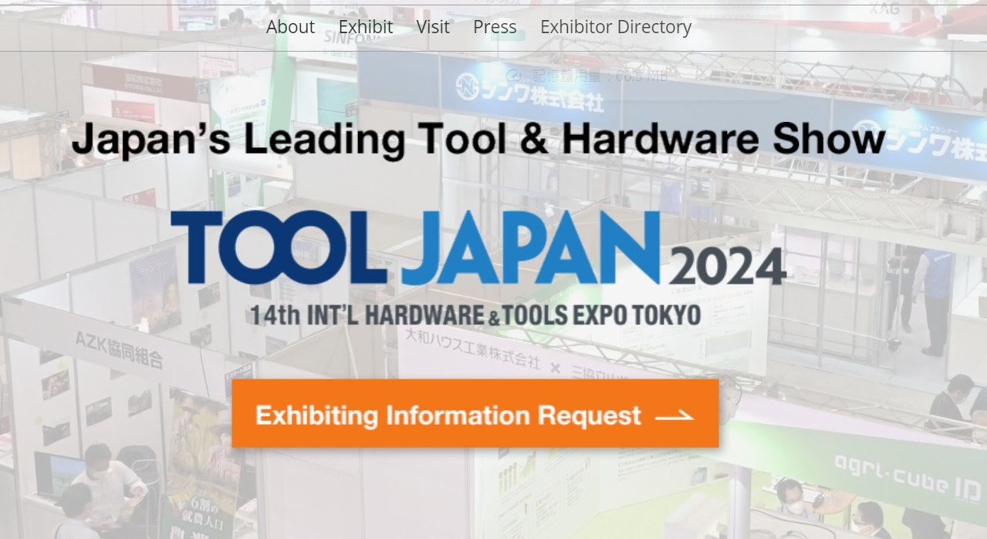
Source: https://www.tooljapan.jp/en-gb.html

Service Support

- Customer online services
Since we do not have any physical stores in Japan, we will ensure that any customer questions can be addressed promptly. We offer online customer service to handle various issues such as refunds, exchanges, product inquiries, and more.

- Product information and User guidance
Customers might require detailed information on how to use the floral shears effectively, so we will provide comprehensive manuals in Japanese (included with the product), instructional videos (YouTube), and online tutorials (YouTube).
- Loyalty Programs
Implement a loyalty program that rewards repeat customers with discounts, exclusive access to new products, or special promotions.
- After-Sales Follow-Up
Follow up with customers post-purchase to ensure satisfaction and address any potential issues proactively. This can be done through automated emails or personal calls. We encourage customers to post their user feedback on our Facebook or Instagram because we believe these real user experiences are crucial for our improvement.
"Reliability," "Integrity," and "Quality" are the values we emphasize. Therefore, we will make every effort to uphold these values in all our interactions and transactions.

Conclusion
- By focusing on demographic and psychographic factors, we have identified distinct target markets for our floral shears.
- Our product positioning strategy ensures that Gorilla tools stand out in the Japanese market.
- Pricing will be determined through a combination of market-oriented and value-based strategies, ensuring competitiveness while highlighting the unique value of our products.
- Our distribution strategy will leverage the most popular online platforms in Japan, including Rakuten Ichiba, Amazon Japan, and Yahoo! Shopping.
- Promotion will focus on digital and media channels such as YouTube, TikTok, and Instagram, along with participation in the International Hardware & Tools Expo Tokyo and we will collaborate with popular Japanese YouTubers.
- Additionally, we will provide robust online customer service to address inquiries, refunds, and exchanges.
- By implementing these strategies, we are confident that Gorilla can establish a strong presence in the Japanese market, offering high-quality, multifunctional, and user-friendly hand tools that meet the needs of diverse customer segments.

